



Essay / Assignment Title: Predictive Modelling for Credit Card Default Using Machine Learning
Programme title:

Name:

Year:

CONTENTS

CONTENTS 2
Task 1: Exploratory Data Analysis 4
Task 2: Data Preparation 6
Task 3: Model Training 7
Task 4: Model Evaluation and Visualisation 8
Task 5: Conclusion and Future Work 11
BIBLIOGRAPHY 12

Statement of compliance with academic ethics and the avoidance of plagiarism

I honestly declare that this dissertation is entirely my own work and none of its part has been copied from printed or electronic sources, translated from foreign sources and reproduced from essays of other researchers or students. Wherever I have been based on ideas or other people texts I clearly declare it through the good use of references following academic ethics.
(In the case that is proved that part of the essay does not constitute an original work, but a copy of an already published essay or from another source, the student will be expelled permanently from the postgraduate program).

Name and Surname (Capital letters):

.......................................................................................................................................

Date: ........................./........../.........

Task 1: Exploratory Data Analysis
Credit card default prediction is a supervised machine-learning classification problem where customer, financial, repayment and risk variables are used to predict whether a client will default next month. We have been given a dataset called Credit_Card.csv which contains 34,788 records and 30 different features these include demographic features, credit limit, repayment history, bill amount, payment amount, RISK_RATING, risk_leak and default.payment.next.month which is the target variable. The accuracy, precision, recall, F1-score and ROC-based metrics are often used to assess the performance of machine-learning models in recent peer-reviewed studies on credit risk that use these models (Chang et al., 2024).
Moderate class imbalance is observed for the target variable, with 80.87% of the customers being non-defaulters and 19.13% being defaulters. This imbalance requires more than accuracy, since a model might be seemingly successful by predicting the majority class the vast majority of the time.
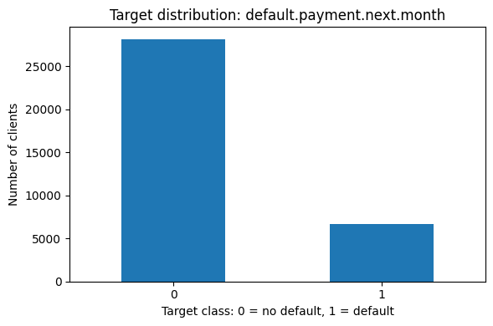
Figure 1: Target Distribution
Descriptive statistics were created for LIMIT_BAL, AGE, BILL_AMT_SUM, LIMIT_BAL_LOG, and risk leak. The financial variables were highly skewed with outliers present, particularly LIMIT_BAL and BILL_AMT_SUM. This indicated that there was a need for strong preprocessing.
These variables SEX, EDUCATION, MARRIAGE, CITY, and RISK_RATING undergo a categorical analysis. In RISK_RATING Clients are categorized into 1 with 11.79% and 3 with 68.10% of defaults rates. That was the best grouping pattern.

Figure 2: Default rate by RISK_RATING
Based on the risk leak, default had the highest correlation at 0.9689, followed by RISK_RATING, PAY_0, PAY_2, and PAY_3.
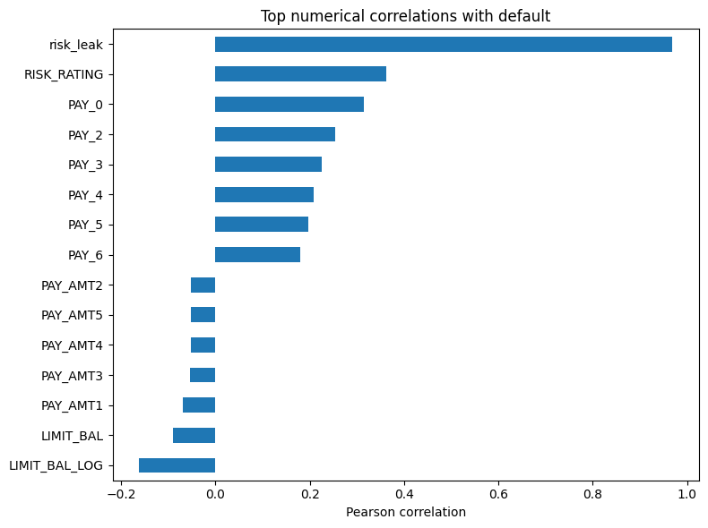
Figure 3: Top numerical correlations with default
These results indicated that the most important variables for predicting default were risk-related variables and recent repayment behavior.

Task 2: Data Preparation
The missing-value audit identified missing data in several columns, including SEX at 5.08%, AGE at 5.04%, PAY_AMT2 at 5.01%, EDUCATION at 4.98%, MARRIAGE at 4.98%, PAY_AMT1, LIMIT_BAL, and LIMIT_BAL_LOG. Before preprocessing, AGE, LIMIT_BAL and PAY_AMT2 contained missing values; after median imputation inside the pipeline, these variables contained no missing values in the transformed training matrix.
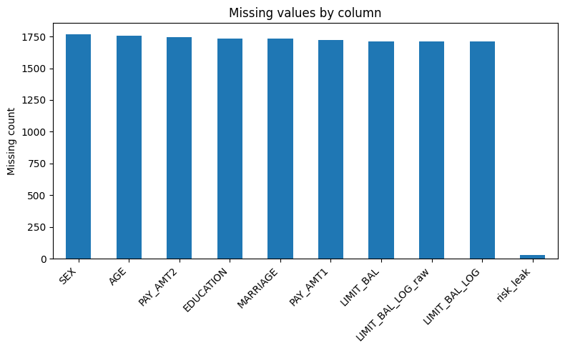
Figure 4: Missing values by column
No rows were deleted as removing all incomplete records would affect the size of the dataset and hence the class balance. In contrast, the variables that were numerical were filled in with the median, since there were outliers and the distributions were skewed in the financial variables. Categorical variables had the most common value given.
Categorical variables were encoded for machine-learning algorithms. The StandardScaler was used to scale numerical variables which was crucial for Logistic Regression, Support Vector Machine and K-Nearest Neighbours. All preprocessing was applied within a pipeline to ensure that only imputation, encoding and scaling of the training data were learned. This avoids leakage of data during preprocessing. LIMIT_BAL_LOG was treated with care since it was related to LIMIT_BAL, and the extremely high correlation of risk_leak with the target was treated as a special case since it might indicate data leakage.

Task 3: Model Training
The data has been separated and divided into sets for training and testing at an 80:20 ratio. Since the default class only made up 19.13% of the data and the training and testing sets had to have the same class proportions, stratification was used. Six statistical models—Logistic Regression, Linear Support Vector Machine, Decision Tree, Random Forest, K-Nearest Neighbors, and Gradient Boosting—had been utilized with their default hyperparameters. Linear algorithms, margin-based algorithms, distance-based algorithms, tree-based algorithms, and ensemble algorithms were among the preferred algorithms.
The risk_leak variable was not included in the main modelling experiment, as it was suggested by the EDA to be likely to reflect target information. A secondary diagnostic experiment was conducted including risk_leak to check to see if it led to unrealistic performance. This two-stage design allowed the modelling to be more believable with a separation of features that were deployed as predictions from ones that may have leaked. An analysis of the systematic review evidence points to the use of demographic, operational and payment-behaviour variables as key characteristics in credit-risk models, thereby justifying the emphasis on repayment status and credit risk rating features in this experiment (Noriega, Rivera and Herrera, 2023).
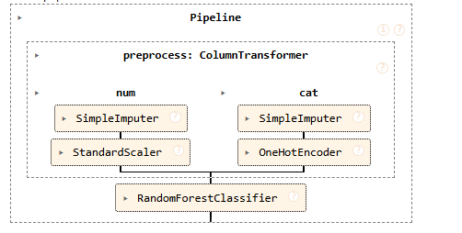
Figure 5: Random Forest Pipeline

Task 4: Model Evaluation and Visualization
To assess each model F1-score, AUC-ROC, accuracy, precision, and recall is used. The Random Forest is the best default model in the primary experiment without risk leak, that has an F1-score of 0.4657, recall of 0.3238, AUC-ROC of 0.8732, precision of 0.8288. Decision tree was the weakest with AUC-ROC value of 0.6638 and Gradient Boosting was in second place with AUC-ROC value 0.7897.
Table 1: Model comparison across all classifiers
 | model | accuracy | precision | recall | f1_score | auc_roc
0 | Random Forest | 0.8579 | 0.8288 | 0.3238 | 0.4657 | 0.8732
1 | Gradient Boosting | 0.8413 | 0.6587 | 0.3539 | 0.4604 | 0.7897
2 | Logistic Regression | 0.8229 | 0.5950 | 0.2329 | 0.3348 | 0.7512
3 | Linear SVM | 0.8186 | 0.5729 | 0.2036 | 0.3004 | 0.7494
4 | KNN | 0.8317 | 0.6133 | 0.3253 | 0.4251 | 0.7320
5 | Decision Tree | 0.8343 | 0.6042 | 0.3877 | 0.4723 | 0.6638
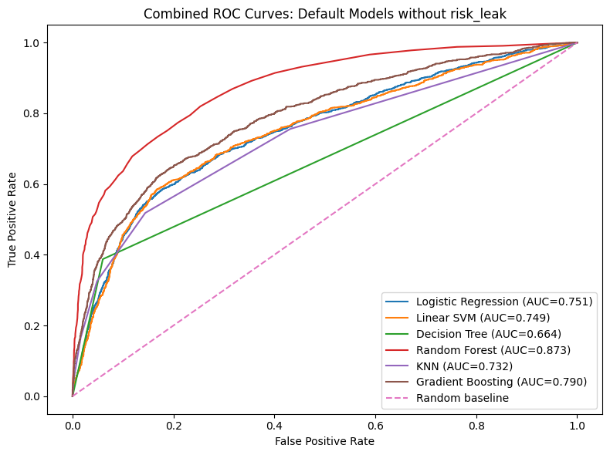
Figure 6: Combined ROC curves without risk leak
Peer-reviewed credit card default research also compares models like Logistic Regression, SVM, Random Forest and Boosting models to find the best model for credit card default prediction (Bhandary and Ghosh, 2025).
The secondary experiment had AUC-ROC values close to 1 in most of the models, which had an AUC-ROC value of 0.9965 with the exception of KNN. This demonstrated that risk leak was probably a leakage variable and that the realistic model shouldn't include it. The model was fine-tuned using Random Forest and Randomized Search CV after the AUC-ROC was chosen. The F1-score of 0.4504, recall of 0.3140, and AUC-ROC of 0.8192 is produced adjusted Random Forest. Despite the fact that this was less than the default Random Forest test AUC, A more reliable estimate of model performance is produced after the Cross-validation adjustment.
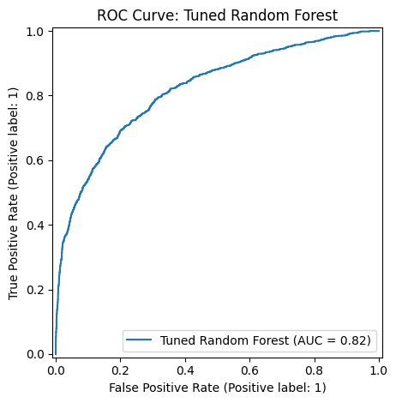
Figure 7: ROC Curve for Tuned Random Forest
Model interpretation was carried out using SHAP. The top three features for the tuned Random Forest that did not use the risk_leak variable were PAY_0, RISK_RATING, and PAY_2 which show that the recent repayment delay and risk classification were the most important.
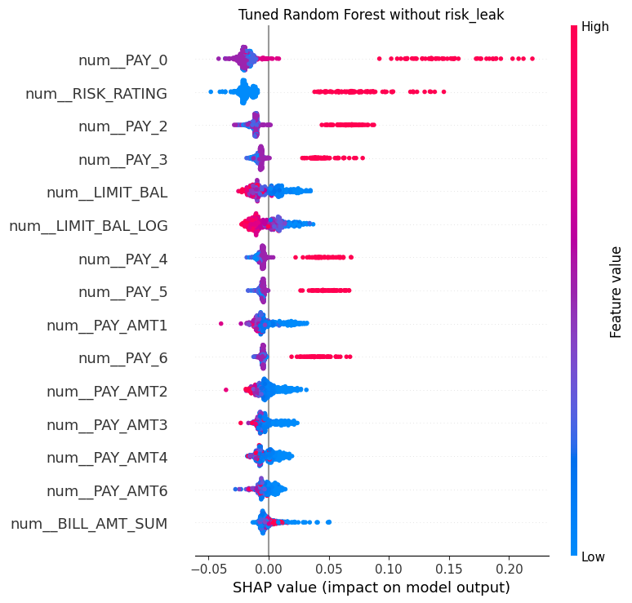
Figure 8: SHAP summary without risk_leak
A recent article published in the Journal of Risk and Systems Risk suggests that SHAP can be used to generate explanations for credit-risk models, but the stability of these explanations needs to be verified prior to deployment in financial applications of high stakes (Lin & Wang, 2025).

Task 5: Conclusion and Future Work
Overall, Random Forest was the most powerful realistic model, scoring the highest AUC-ROC among the default models and it also supported non-linear relationships between financial variables, risk rating, and repayment history when risk_leak was not included. Gradient Boosting gave a good result and Logistic Regression, Linear SVM and KNN were moderate. Decision Tree was the weakest, which may be due to its tendency for overfitting and instability as compared to other ensemble methods. The interpretation results were that recent repayment behaviour (PAY_0, PAY_2), risk rating (RISK_RATING), and the other scores were more important than the demographic variables or the raw billing totals.
The main limitation was the presence of the risk_leak variable. Because of its almost perfect correlation with the target, the value of its model results is unrealistic and it was not used in the main model. The class imbalance is the other problem. The recall was poor (0.3238) for the default class indicating that a large number of true defaulters were not identified, but the AUC-ROC and the precision were good. One drawback was the absence of values for some cells. The choices of median and most-frequent imputation were practical alternatives that could have the effect of diminishing natural variation in the data. Lastly, differences in rates of recall and false-positive rates were found across various demographic groups (e.g., EDUCATION, MARRIAGE), that could lead to unequal experiences in real financial decision-making. Research on the topic of fair risk-scoring gives caution that even when using protected attributes is not deliberate, machine-learning models can still yield discriminatory outcomes within subgroups (Szepannek and Lübke, 2021).
First, class imbalance should be tackled by applying class weighting, threshold adjustment or SMOTE based resampling, as too many defaulters were missed when using the current model fairness metric, recall. Second, the fairness audit needs to be extended to include a comparison of the recall rate, false-positive rate, and the impact of approval by demographic group (as initial results indicated that there were different false-positive rates across EDUCATION and MARRIAGE). Third, the model needs to be tested on a more recent external data set as the existing data set is from a different time and may not be representative of the current customer behaviour. Fourth, there should be a formal preprocessing step of leak checks since the leakage experiment demonstrates how a single poorly chosen feature can yield seemingly perfect results. These enhancements are directly addressing the perceived limitations and would render the model more reliable, fair and applicable to real-life use.

BIBLIOGRAPHY

Bhandary, R. and Ghosh, B.K. (2025) 'Credit Card Default Prediction: An empirical analysis on predictive performance using statistical and machine learning methods,' Journal of Risk and Financial Management, 18(1), p. 23. https://doi.org/10.3390/jrfm18010023.
Chang, V. et al. (2024) 'Credit risk prediction using machine learning and Deep Learning: A study on Credit card customers,' Risks, 12(11), p. 174. https://doi.org/10.3390/risks12110174.
Lin, L. and Wang, Y. (2025) 'SHAP stability in credit risk Management: A case study in Credit card default model,' Risks, 13(12), p. 238. https://doi.org/10.3390/risks13120238.
Noriega, J.P., Rivera, L.A. and Herrera, J.A. (2023) 'Machine Learning for Credit Risk Prediction: A Systematic Literature Review,' Data, 8(11), p. 169. https://doi.org/10.3390/data8110169.
Szepannek, G. and Lübke, K. (2021) 'Facing the challenges of developing fair risk scoring models,' Frontiers in Artificial Intelligence, 4, p. 681915. https://doi.org/10.3389/frai.2021.681915.

